Steps to Monitor and Execute DI Pipelines

1. Login to SAP DI Development Environment: <https://apacdidev.mykft.net/>

Enter Tenant Name “**dadapp001**” for Dev.

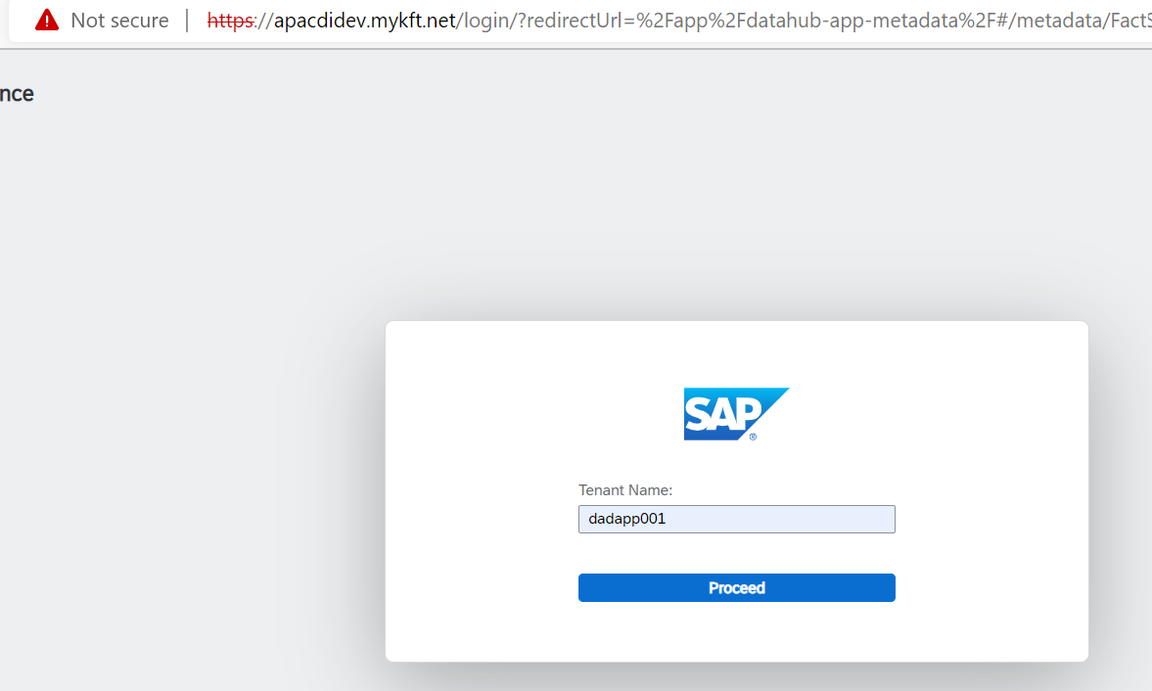

Click on proceed and then enter user id , Password.

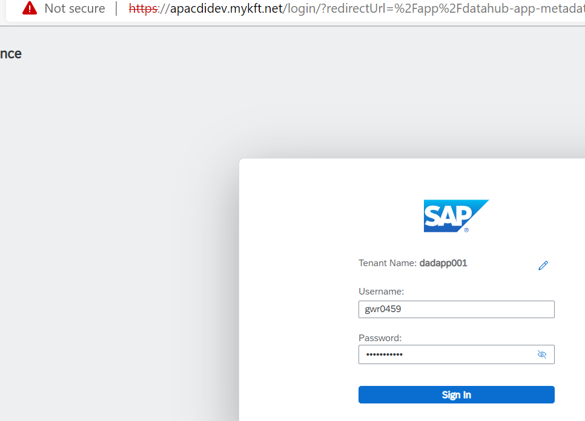

1. For monitoring the Scheduled pipelines , Click on Monitoring component from DI Launchpad.

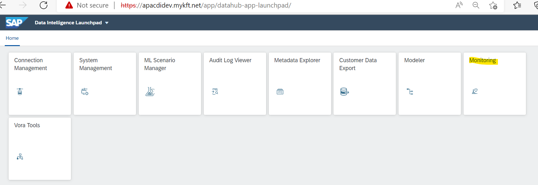

1. From Monitoring window, click on instances to check on last run status.

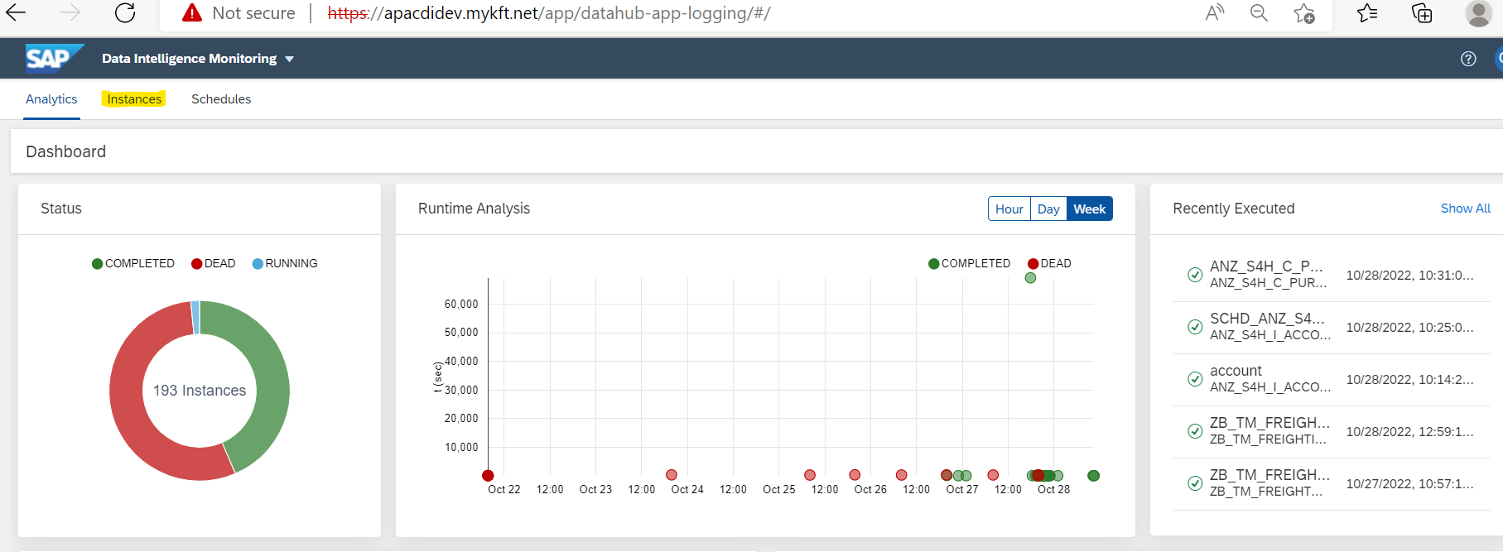

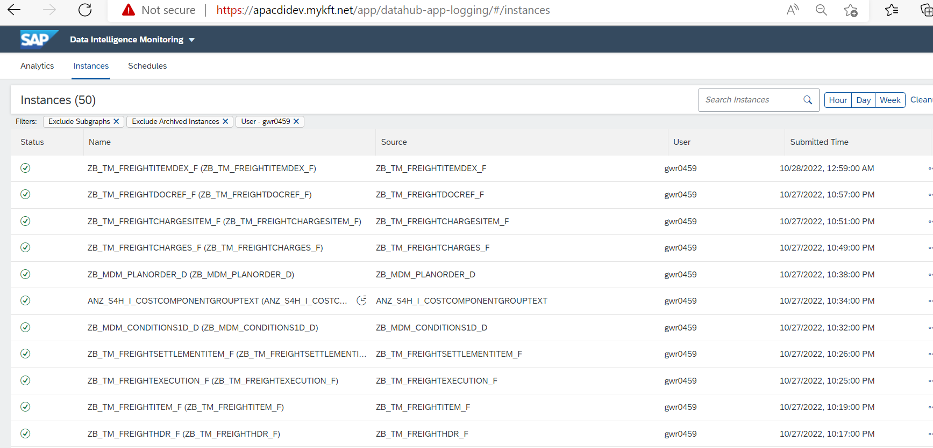

1. On Instances tab , will get the list of pipelines executed. Click on any particular pipeline to see more details. In right pane will see the pipeline structure and other info.

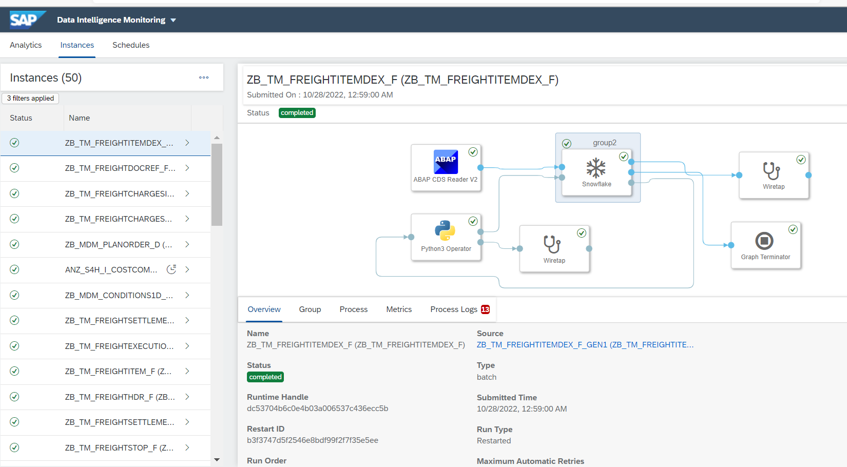

1. To run pipeline ad-hoc click on option –“Open source graph”, it will open the new modeller window on the browser.

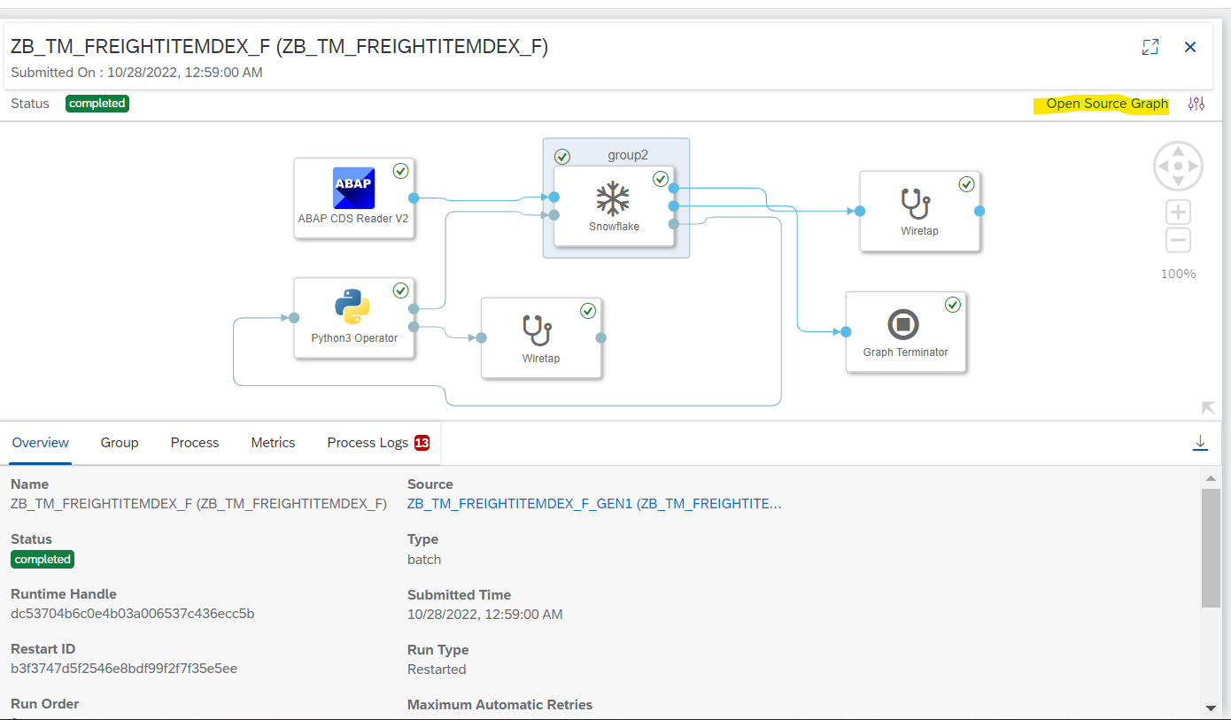

Pipeline will get open in new modeler window.

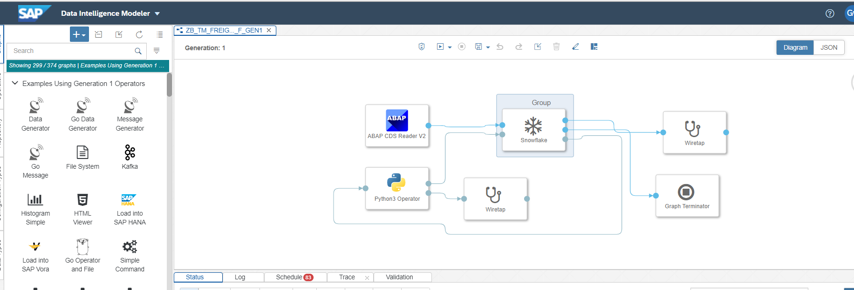

1. Click on run button from the modeler to execute the pipeline instantly.

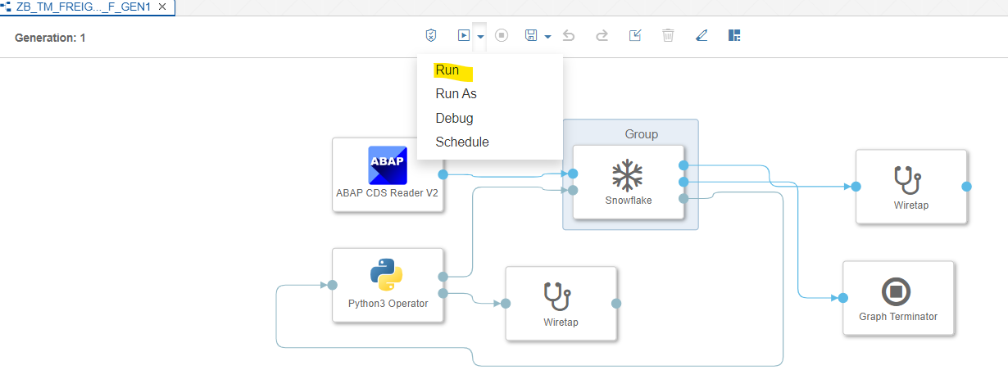

1. Running status of pipeline will be visible under the status tab. Once pipeline runs successfully , status will show as green under completion tab. If pipeline fails then status will show as red under error tab.

